***INTRODUCTION***

The pursuit of understanding happiness and its determinants is a longstanding and multifaceted endeavor. As society continues to evolve, so too does our interest in comprehending the factors that contribute to individual well-being. In this research, I delve into the European Social Survey data for Ireland from 2018 (ESS9IE dataset) to explore the relationships between variables influencing happiness levels. The chosen variables encompass several aspects of societal well-being: gender, age, and internet use frequency. I use SPSS to analyze the data and generate graphs, descriptive statistics and results, and any other tables or charts.

Understanding happiness, a fundamental aspect of well-being, is crucial for societal development and policy formulation. Investigating how gender and age influence happiness contributes to the broader discourse on individual and societal contentment. Additionally, given the contemporary ubiquity of the internet, exploring its relationship with happiness offers insights into the evolving dynamics of human experience in the digital age.

***HYPOTHESES***

1. *Gender (gndr)*

Mahon, Yarcheski, and Yarcheski (2005) conducted a study focusing on adolescents and found no substantial gender-based differences in happiness. Conversely, Giusta, Jewell, and Kambhampati (2011) revealed variations in life satisfaction between men and women. Their analysis of the British Household Panel Survey revealed that while average levels of life satisfaction remained similar between genders, the variability in satisfaction was more pronounced among women. Women’s satisfaction was impacted by factors such as childcare, caring for adults, and hours of housework, while job satisfaction held more weight for men, potentially indicating diverse impacts on happiness levels.

*Hypotheses:*

H0: There is no statistically significant difference in the mean level of happiness between males and females in the population.  
HA: There is a statistically significant difference in the mean level of happiness between males and females in the population.

1. *Age of respondent (agea)*

Existing studies offer diverse insights into the correlation between age and happiness. Frijters and Beatton (2012) identified a U-shaped relationship, with an increase in happiness around the age of 60 followed by a decline after 75. This contradicts Palmore and Luikart's (1972) assertion that variables like age might not significantly influence life satisfaction. Therefore, while some research suggests an age-related impact on happiness, other perspectives propose limited or negligible associations between age and life satisfaction.

*Hypotheses:*

H0: There is no statistically significant correlation between age and the level of happiness among respondents in the population.HA: There is a statistically significant correlation between age and the level of happiness among respondents in the population.

1. *Internet use, how often (netusoft)*

The hypothesis regarding the effect of internet use frequency on happiness levels draws from contrasting findings in different studies. Pénard, Poussing, and Suire (2013) uncovered evidence suggesting that non-users are less satisfied with life compared to internet users, particularly among younger individuals or those dissatisfied with their income. On the other hand, Lelkes (2013) highlighted a positive relationship between regular internet use, reduced social isolation, and increased life satisfaction among older adults. These varying findings imply a nuanced relationship between internet use frequency and happiness levels, indicating potential differences based on age or satisfaction with other life aspects.

*Hypotheses:*H0: The frequency of internet use does not have a statistically significant effect on the mean level of happiness among individuals in the population.HA: There is a statistically significant effect of internet use frequency on the mean level of happiness among individuals in the population.

***DESCRIPTIVE STATISTICS AND GRAPHS***

1. *How happy are you (happy) (ordinal/scale)*

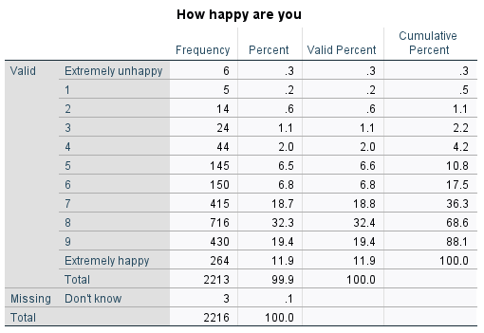

Table

The variable "How happy are you" presents a range of responses on a scale from 0 (“Extremely unhappy”) to 10 (“Extremely happy”). The dataset comprises responses from 2216 individuals (3 missing).

The frequency distribution (Table 1) displays the distribution of responses across the happiness scale. Notably, the most common responses lie between 7 and 9, with 32.4% of respondents reporting a happiness level of 8 and 19.4% reporting a level of 9. Additionally, lower happiness levels (below 5) have relatively lower frequencies, with extremely unhappy responses accounting for only 0.3% and 1% of respondents reporting a happiness level of 1.

|  |
| --- |
| Table |

The descriptive statistics (Table 2) display that the mean happiness level is calculated at 7.70, indicating a relatively high average level of happiness among respondents. The median, at 8.00, aligns closely with the mean, indicating a symmetrical distribution without extreme outliers. The variance of 2.735 and standard deviation of 1.654 suggest a moderate level of dispersion around the mean happiness score. The negative skewness (-1.119) indicates that the distribution of happiness scores is moderately skewed to the left. This suggests that the distribution has a longer tail on the left side, with more respondents reporting higher happiness levels. The kurtosis value of 2.073 suggests a relatively normal distribution with slightly heavier tails than a normal distribution.

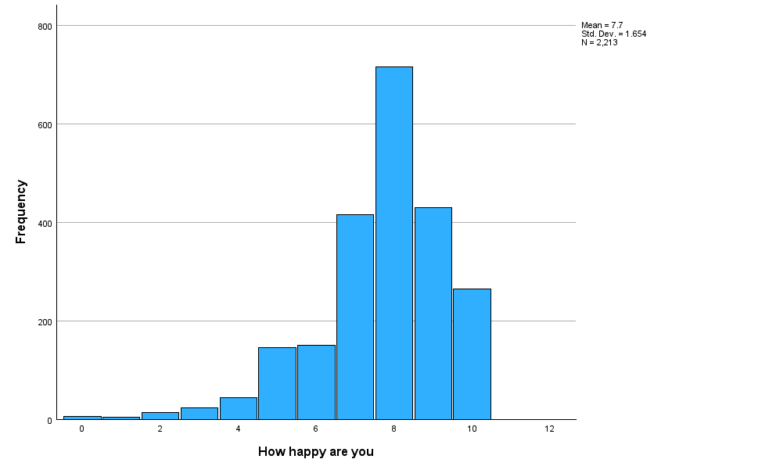

Figure

Analyzing the histogram (Figure 1), which illustrates the percentage of respondents at each happiness level, indeed confirms the findings from the descriptive statistics. The shape of the histogram aligns with the negative skewness observed in Table 2, with a concentration of respondents towards the higher happiness levels (7-9), and with smaller percentages of respondents reporting lower happiness levels (0-6), evident from the left side of the histogram.

1. *Gender (gndr) (nominal)*

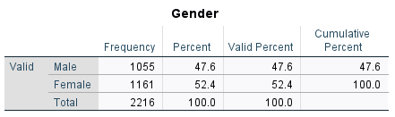

Table

The frequency table (Table 3) shows that the distribution of gender within the dataset is almost balanced, with slightly more females (52.4%) than males (47.6%).

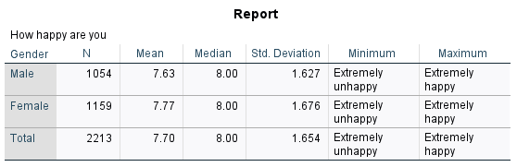

Table

When comparing the happiness levels between genders (Table 4), females tend to report slightly higher mean (mean score of 7.77) happiness scores than males (mean score of 7.63). However, both genders generally exhibit similar median scores, indicating that a substantial portion of respondents from both groups reported high levels of happiness (median of 8.00). The standard deviation for both genders is relatively low (1.627 for males and 1.676 for females), indicating that the happiness scores are closely clustered around the mean.

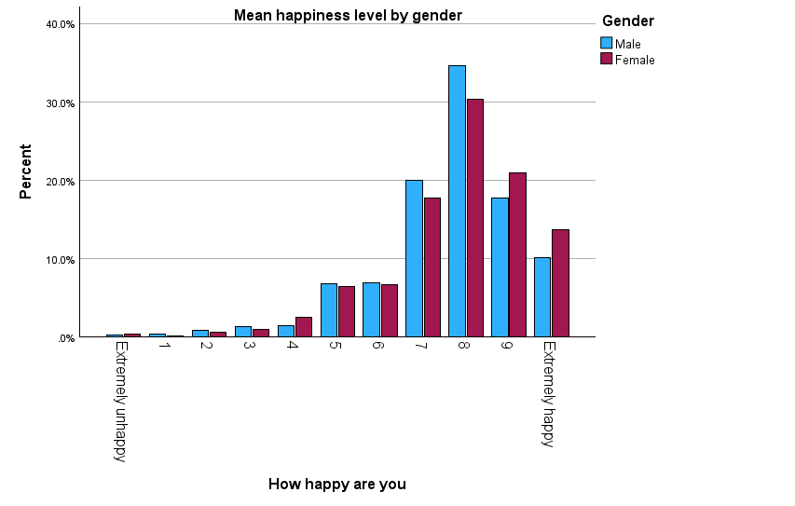

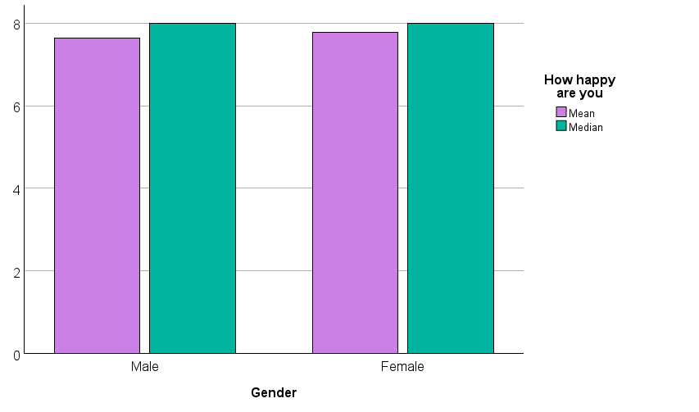

Figure

The bar chart visually reinforces the similarity in mean happiness levels between genders. Both groups tend to report high happiness levels, as the bars are positioned toward the upper end of the scale.

1. *Age of respondent (agea) (scale)*

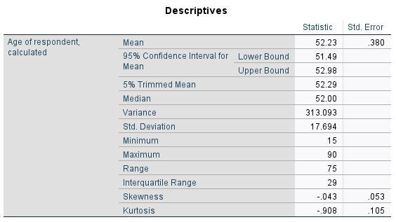

Table

The descriptive statistics (Table 5) display that the average age of respondents is 52.23 years and the age ranges from the youngest at 15 to the oldest at 90 years old.

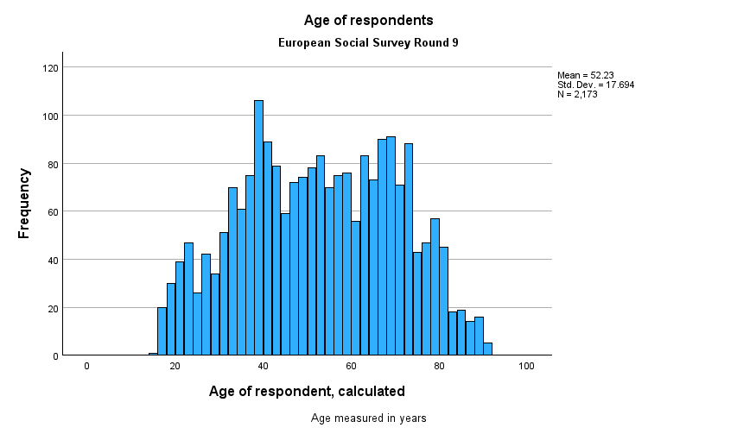

Figure

The histogram (Figure 3), showcasing a distribution close to normality, aligns with our observations in Table 5. The skewness of -0.043 suggests a slightly left-skewed distribution, although the magnitude is very small. The kurtosis of -0.908 indicates a distribution that is less peaked than a normal distribution. This suggests that the age distribution has relatively lighter tails.

1. *Internet use, how often (netusoft) (ordinal)*

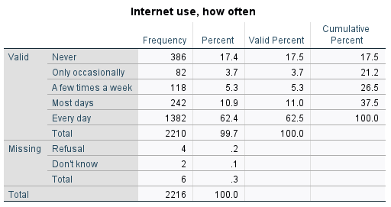

Table

The frequency distribution (Table 6) displays varying patterns of internet use among respondents. The majority (62.5%) report using the internet every day, while smaller proportions report using it most days (11.0%), a few times a week (5.3%), only occasionally (3.7%), and never (17.5%).

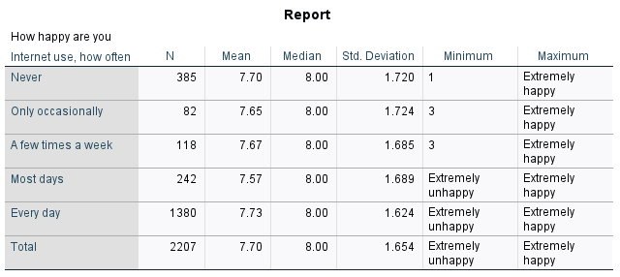

Table

The data (Table 7) shows that, on average, respondents who use the internet every day report slightly higher mean happiness (7.73) compared to those who use it only occasionally (7.65) or a few times a week (7.67). Interestingly, respondents who never use the internet have a mean similar to those who use it every day, which can be visually seen in the Figure 4. The median is 8.00 across all categories, indicating that the majority of respondents in each group report a high level of happiness. The standard deviation of 1.654 suggests some variability in reported happiness levels.

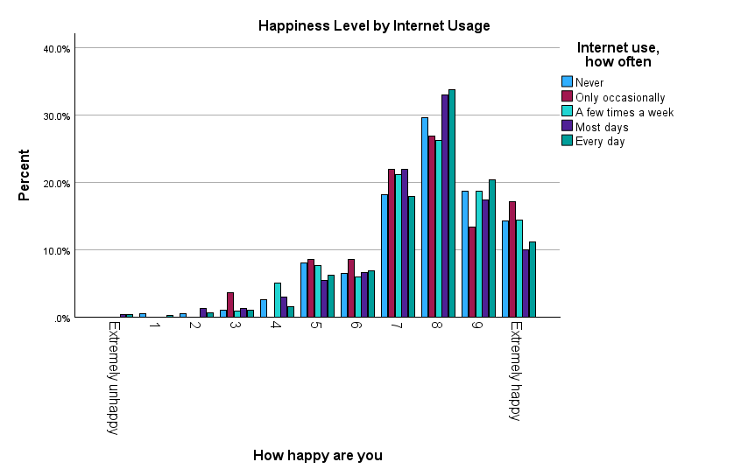

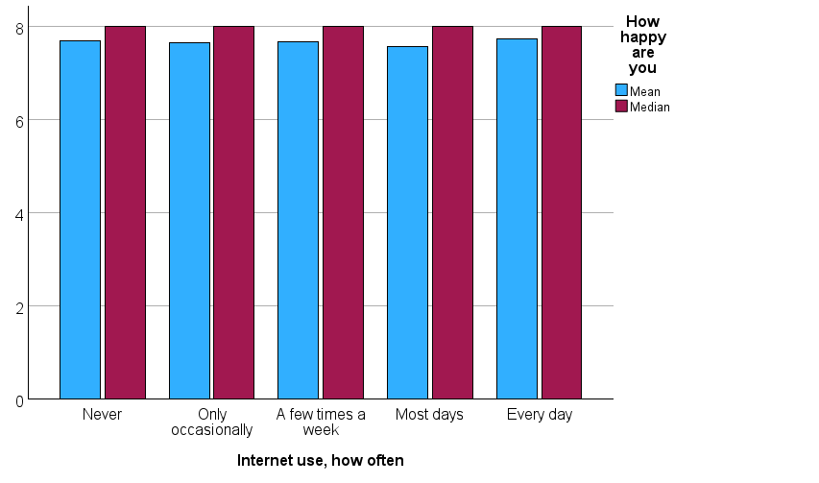

Figure

***STATISTICAL TESTS***

1. *Gender (gndr) (nominal)*

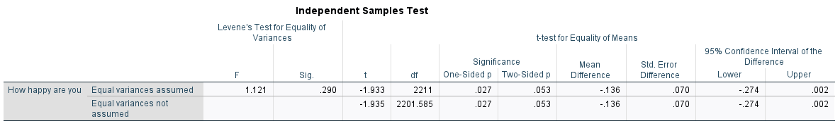

Table

In examining the relationship between gender and happiness levels, an independent samples t-test was employed.  
Under the 'Sig. (two-sided p)' column, we see a figure of 0.053 > 0.05.  
The score for Sig. exceeds 0.05, meaning that our test is not statistically significant and that there is not enough evidence to reject the null hypothesis. Therefore, we cannot conclude that there exists a statistically significant difference in overall happiness level between genders based on this analysis.   
Several studies shed light on gender differences in happiness and subjective well-being. Mohsen Joshanlo's (2018) study across 150 nations revealed similarities in predictors of life satisfaction between genders, emphasizing socio-political and employment, and educational-related variables' impact on men's satisfaction and marital status and relationships' significance for women.

Chui and Wong's (2016) study on gender differences in happiness and life satisfaction among adolescents in Hong Kong provides additional context. While their study focused on adolescents, it still emphasizes the nuanced relationships between various factors and subjective well-being among genders. They noted that while family factors like parents' marital status displayed a weak effect, self-esteem, purpose in life, and the number of close friends played significant roles in predicting happiness, with a stronger impact on females. Interestingly, for girls, academic performance is a way to pursue a more successful and fulfilling life, impacting their happiness, while boys may see it as an achievement in itself.

Moreover, Lepinteur et al. (2022) observed changes in loneliness and life satisfaction during the COVID-19 pandemic, with a disproportionate rise in loneliness among women, influencing their life satisfaction compared to men. While not directly reflective of our analysis, this study emphasizes the gender-specific effects on subjective well-being, supporting the notion that external factors may differently impact happiness levels across genders.

1. *Age of respondent (agea) (scale)*In examining the relationship between age and happiness levels, two types of analysis were used: Correlation (Table 9) and Regression (Table 10,11,12).

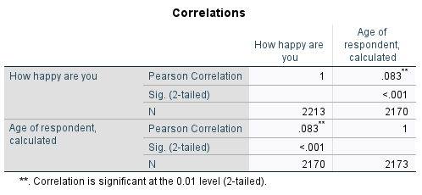

Table

The correlation analysis was conducted to assess the strength and direction of the relationship between age and happiness. The results revealed a statistically significant correlation between age and happiness, r = 0.083, p < 0.001. This indicates a positive correlation, suggesting that as age increases, there is a slight increase in reported happiness levels. The correlation coefficient, though statistically significant, suggests a weak relationship, as the coefficient is relatively small.

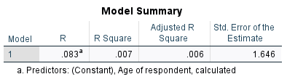

Table

The regression analysis further elucidates the relationship between age and happiness. The model summary (Table 10) indicates that age accounts for approximately 0.7% (R-squared = 0.007) of the variance in self-reported happiness levels. This modest R-squared value suggests that age alone explains a small proportion of the variability in happiness scores.

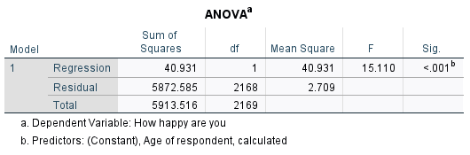

Table

The analysis of variance (ANOVA) tests the overall significance of the regression model. The results indicate that the regression model is statistically significant (F = 15.110, p < 0.001). This suggests that the variation in happiness levels can be partially explained by age.

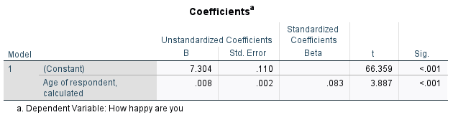

Table 12

The coefficient for age (0.008) signifies that for every one-unit increase in age, there is an associated increase of 0.008 in the self-reported happiness score. The positive sign of the coefficient indicates a positive relationship, supporting the correlation findings (Table 9).

The correlation and regression analyses collectively support the rejection of the null hypothesis and accept the alternative hypothesis that there is a statistically significant correlation between age and the level of happiness among respondents. While statistically significant, the correlation coefficient of 0.083 (Table 9) denotes a weak positive relationship between age and self-reported happiness. The regression model confirms this relationship, indicating that although age accounts for a small percentage of the variance in happiness scores, it remains a statistically significant predictor.

The positive correlation implies that, on average, as individuals get older, there is a slight increase in reported happiness levels. This finding aligns with the U-shaped relationship observed in studies of Frijters and Beatton (2012), indicating that happiness tends to decrease during midlife and increase in later years. Moreover, Galambos et al. (2015) identified a nonlinear trend in happiness across age groups, noting an increase in happiness from the late teens and early 20s into the early and late 30s, followed by a slight downturn by the early 40s.

Additionally, Helliwell et al. (2019) highlighted the influence of external factors such as workplace environment, community belonging, and relationship status on the U-shaped pattern of happiness across ages. They suggested that a strong sense of community belonging could elevate life satisfaction, especially in older age groups.

1. *Internet use, how often (netusoft) (ordinal)*

In examining the relationship between internet use frequency and happiness levels, two types of analysis were used: Correlation (Table 13) and Regression (Table 14,15,16).

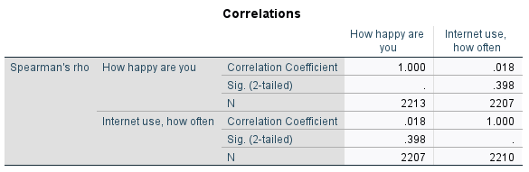

Table 13

Correlation coefficients (Table 13) were calculated to examine the relationship between internet use frequency and self-reported happiness levels. The Spearman's rho correlation coefficient between these two variables was found to be 0.018, with a p-value of 0.398. Since p=0.398> 0.05, there is no strong evidence to reject the null hypothesis. The correlation coefficient of 0.018 indicates a very weak positive correlation, implying that as internet use frequency increases, there is a slight increase in self-reported happiness, though the relationship is not statistically significant.

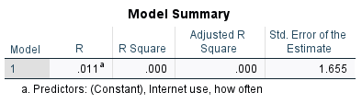

Table 14

The Model Summary table (Table 14) presents the overall fit of the regression model. The R Square value is close to zero (0.000). This suggests that the model with internet use frequency as a predictor does not explain a significant amount of the variability in self-reported happiness.

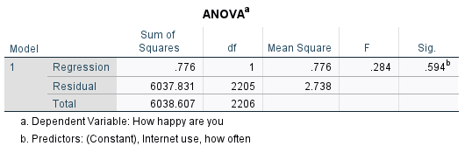

Table 15

Moreover, in the ANOVA table (Table 15), the p-value associated with the F-statistic is 0.594, which is much higher than the significance level of 0.05. This again shows that we don’t have enough evidence to reject the null hypothesis, reinforcing the idea that internet use frequency does not have a substantial effect on the mean level of happiness in this specific population.

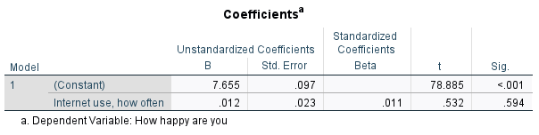

Table 16

The coefficients table (Table 16) indicates that, for a one-unit increase in internet use frequency, the mean level of happiness is expected to increase by 0.012 units. However, the p-value is not statistically significant, suggesting that this relationship is not likely a true effect but rather could be due to random chance.

The literature presents diverse perspectives on the relationship between internet use and happiness. Hall and Banaszek (2014) propose that the Internet, by facilitating social communication and connections, is associated with higher levels of happiness and well-being. However, it contrasts with the results from Muñiz-Velázquez et al.'s study (2021) during the COVID-19 confinement, where higher media consumption, including social networking sites, was negatively correlated with happiness. Moreover, Hall (2016) found a negative relationship between time spent on the internet and reported happiness levels, indicating that prolonged internet use might adversely affect one's happiness measures. The nuanced relationship between internet use and happiness becomes evident, suggesting that the impact may vary based on factors such as the context and nature of online activities.

***CONCLUSION***

In conclusion, the study explored the relationships between gender, age, internet use frequency, and self-reported happiness levels, drawing insights from statistical analyses and existing literature.

Gender analysis yielded non-statistically significant differences in happiness levels between males and females, aligning with diverse studies showcasing nuanced predictors of life satisfaction across genders. Age, while showing a statistically significant yet weak positive correlation with happiness, emphasized a modest role in explaining the variance in reported happiness scores. This echoes the U-shaped trend observed in some studies, where happiness tends to increase in later years.  
Regarding internet use frequency, the findings did not reveal a statistically significant effect on self-reported happiness levels. Contrasting perspectives in literature showcased the complexity of this relationship, with studies highlighting the potential positive influence of internet use on well-being through social connections, but others revealing negative correlations between excessive media consumption and happiness levels.  
The sample characteristics in the ESS9IE dataset for Ireland in 2018 might limit generalizability. Demographic representation biases or exclusions could limit broader applicability, as certain groups may be overrepresented or underrepresented. Moreover, variable measurement and definitions, especially for subjective constructs like "happiness" and "internet use frequency," may lack universal standards across cultures or ages, impacting accuracy and comparability across diverse contexts. Further research could delve deeper into the nuanced dynamics of gender, age, and internet use in influencing happiness levels. Exploring additional variables like social relationships, employment status, and mental health could enhance the understanding of subjective well-being. In essence, while this study provides valuable insights into the factors influencing happiness, it underscores the multifaceted nature of subjective well-being, necessitating comprehensive exploration and consideration of various contributing elements

***REFERENCES:***

Chui, W.H. and Wong, M.Y., 2016. Gender differences in happiness and life satisfaction among

adolescents in Hong Kong: Relationships and self-concept. *Social Indicators Research*, *125*, pp.1035-1051. <https://doi.org/10.1007/s11205-015-0867-z>

Della Giusta, M., Jewell, S.L. and Kambhampati, U.S., 2011. Gender and life satisfaction in the UK. *Feminist Economics*, *17*(3), pp.1-34. [10.1080/13545701.2011.582028](https://doi.org/10.1080/13545701.2011.582028)

Frijters, P. and Beatton, T., 2012. The mystery of the U-shaped relationship between happiness and age. *Journal of Economic Behavior & Organization*, *82*(2-3), pp.525-542. <https://doi.org/10.1016/j.jebo.2012.03.008>

Galambos, N.L., Fang, S., Krahn, H.J., Johnson, M.D. and Lachman, M.E., 2015. Up, not down: The age curve in happiness from early adulthood to midlife in two longitudinal studies. Developmental psychology, 51(11), p.1664. <https://psycnet.apa.org/doi/10.1037/dev0000052>

Hall, R.H., 2016. Internet use and happiness. In *HCI in Business, Government, and Organizations: eCommerce and Innovation: Third International Conference, HCIBGO 2016, Held as Part of HCI International 2016, Toronto, Canada, July 17-22, 2016, Proceedings, Part I 3* (pp. 37-45). Springer International Publishing. <https://doi.org/10.1007/978-3-319-39396-4_4>

Hall, R.H. and Banaszek, A., 2014. The internet, happiness, and social interaction: a review of literature. In *HCI in Business: First International Conference, HCIB 2014, Held as Part of HCI International 2014, Heraklion, Crete, Greece, June 22-27, 2014. Proceedings 1* (pp. 166-174). Springer International Publishing.

<https://doi.org/10.1007/978-3-319-07293-7_16>

Helliwell, J.F., Huang, H., Norton, M.B. and Wang, S., 2019. *Happiness at different ages: The social context matters* (pp. 455-481). Springer International Publishing. <https://doi.org/10.1007/978-3-030-15835-4_20>

Joshanloo, M., 2018. Gender differences in the predictors of life satisfaction across 150 nations. *Personality and Individual Differences*, *135*, pp.312-315. <https://doi.org/10.1016/j.paid.2018.07.043>

Lelkes, O., 2013. Happier and less isolated: Internet use in old age. *Journal of Poverty and Social Justice*, *21*(1), pp.33-46. <https://doi.org/10.1332/175982713X664047>

Lepinteur, A., Clark, A.E., Ferrer-i-Carbonell, A., Piper, A., Schröder, C. and d'Ambrosio, C., 2022. Gender, loneliness and happiness during COVID-19. *Journal of Behavioral and Experimental Economics*, *101*, p.101952. <https://doi.org/10.1016/j.socec.2022.101952>

Mahon, N.E., Yarcheski, A. and Yarcheski, T.J., 2005. Happiness as related to gender and health in early adolescents. *Clinical nursing research*, *14*(2), pp.175-190. <https://doi.org/10.1177/1054773804271936>

Muñiz-Velázquez, J.A., Gómez-Baya, D. and Lozano Delmar, J., 2021. Exploratory study of the relationship between happiness and the rise of media consumption during COVID-19 confinement. *Frontiers in Psychology*, *12*, p.566517.  
<https://doi.org/10.3389/fpsyg.2021.566517>

Palmore, E., & Luikart, C. (1972). Health and Social Factors Related to Life Satisfaction. *Journal of Health and Social Behavior*, *13*(1), 68–80. <https://doi.org/10.2307/2136974>

Pénard, T., Poussing, N. and Suire, R., 2013. Does the Internet make people happier?. *The Journal of Socio-Economics*, *46*, pp.105-116. <https://doi.org/10.1016/j.socec.2013.08.004>